OneShopAI Arena Platform – UI/UX & Frontend Improvement Report
Prepared By: Khwahish Seth
Date: July 2026

Executive Summary
This report presents a comprehensive evaluation of the OneShopAI Arena Platform, focusing on user interface (UI), user experience (UX), gamification, leaderboard functionality, live quiz experience, and overall frontend improvements.
The Arena platform has a strong foundation with a clean, minimal interface and intuitive navigation. However, there are several opportunities to enhance engagement, increase user retention, and create a more immersive competitive environment. This report outlines practical recommendations to transform Arena into a modern, interactive, and gamified competition platform.

Existing Strengths
The Arena platform already provides several positive user experience elements:
- Clean and modern interface
- Easy-to-understand navigation
- Responsive layout across devices
- Good typography and spacing
- Fast event browsing
- Simple registration process
- Organized category filters
- Consistent design language
- Minimalistic and professional appearance
These provide a solid foundation for future improvements.

Major UI & UX Improvement Opportunities
1. Hero Section Enhancement
Current State
The homepage begins with a simple hero section displaying the tagline:
"Compete. Climb. Win."
While visually clean, the section lacks visual excitement and does not immediately communicate the competitive nature of the platform.
Recommended Improvements
Redesign the hero section into a premium landing experience featuring:
- Large 3D Trophy Illustration
- Animated Background
- Floating Quiz Cards
- Live Statistics
- Particle Effects
- Gradient Lighting
- Glassmorphism Design
- Dynamic CTA Buttons
Suggested Live Statistics:
- Active Players
- Live Quizzes
- Upcoming Hackathons
- Prize Pool
- Winners This Week
- Certificates Issued
Benefits
- Creates a stronger first impression
- Clearly communicates platform purpose
- Encourages users to participate immediately
- Increases homepage engagement

2. Improved Call-to-Action (CTA)
Instead of only presenting the tagline, provide multiple action buttons such as:
- Join Live Quiz
- Explore Events
- View Leaderboard
- Organize Competition
- Start Learning
Benefits:
- Faster navigation
- Increased event participation
- Improved conversion rate

3. Live Activity Section
Introduce a dedicated "Live Now" section displaying currently active competitions.
Each card should display:
- Quiz Name
- Live Status
- Participants
- Questions Completed
- Time Remaining
- Join Button
Example:
General Knowledge Quiz
- LIVE
- 352 Participants
- Question 8 of 20
- Ends in 12 Minutes
This creates urgency and encourages users to participate.

4. Homepage Layout Redesign
Recommended homepage flow:
- Navigation Bar
- Hero Section
- Live Events
- Featured Quizzes
- Hackathons
- Tournament Highlights
- Rewards & Achievements
- Why Arena
- Community Highlights
- Testimonials
- Upcoming Events
- Footer
Benefits:
- Better content hierarchy
- Improved user journey
- Increased platform discoverability

5. Event Card Improvements
Current event cards contain limited information.
Recommended additions:
- Prize Pool
- Difficulty Level
- Event Category
- Registration Status
- Duration
- Live Badge
- Number of Questions
- Total Participants
- Event Rating
Hover interactions:
- Elevation
- Glow Effect
- Smooth Scaling
- Animated Buttons
Benefits:
- Richer information
- Improved event comparison
- Better visual engagement

6. Search & Filters
Improve search by adding:
- Auto Suggestions
- Search History
- Popular Searches
- Trending Events
Expand filters:
- Live
- Upcoming
- Completed
- Quiz
- Hackathon
- Tournament
- AI
- Coding
- Design
- Beginner
- Intermediate
- Advanced
Benefits:
- Faster event discovery
- Improved navigation

7. Empty States
Instead of blank pages, display friendly illustrations and messages such as:
"No live events available right now.
Explore upcoming competitions or create your own event."
Benefits:
- Better user guidance
- Reduced bounce rate

8. Loading Experience
Replace traditional loading indicators with:
- Skeleton Screens
- Animated Placeholders
- Progress Bars
- Smooth Fade Animations
Benefits:
- Better perceived performance
- Improved user satisfaction

Leaderboard Improvements
Current Challenges
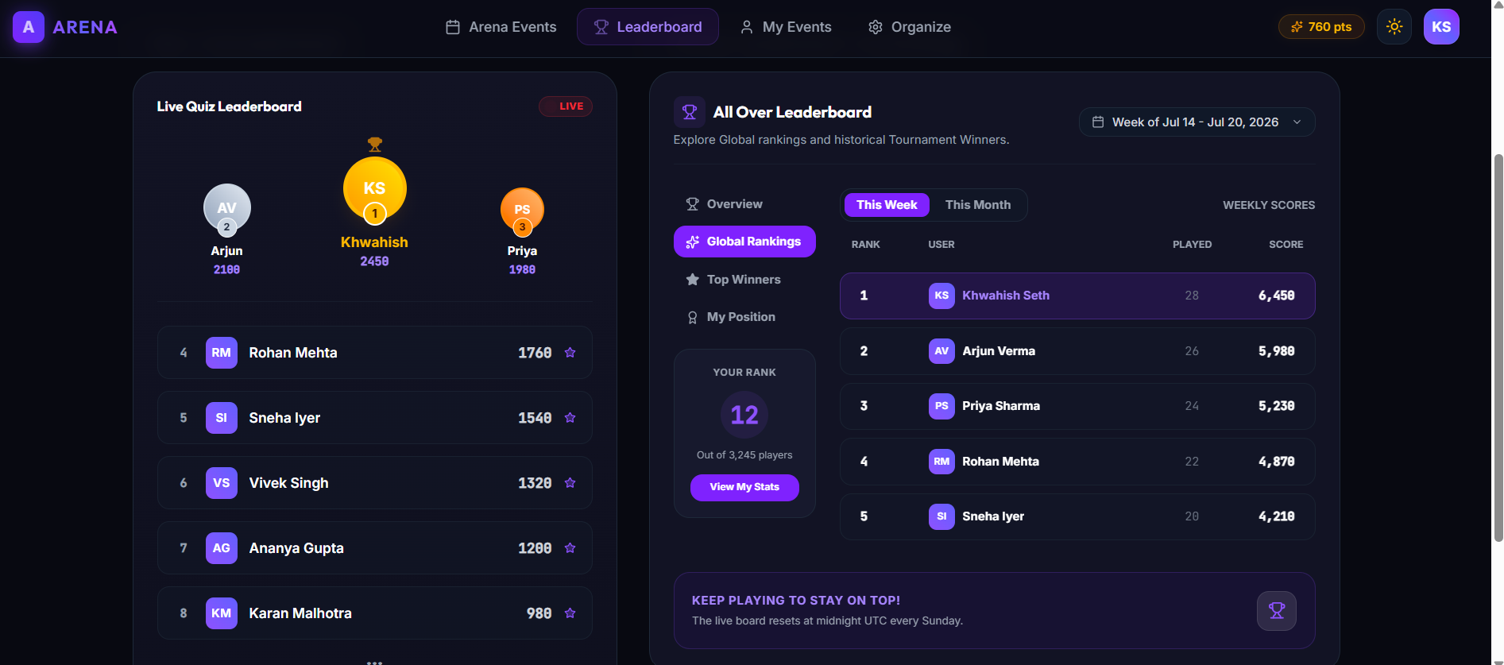
The existing leaderboard presents only a simple podium and ranking list. It lacks motivation, gamification, and personalization.
Issues Identified
- Large unused whitespace
- Static presentation
- Limited ranking information
- No filters
- No weekly or monthly views
- No user progress
- Minimal engagement

Recommended Leaderboard Structure
Create three separate leaderboard experiences:
1. Live Quiz Leaderboard
Purpose:
Display rankings while a quiz is actively running.
Features:
- Live Rankings
- Current Question
- Remaining Time
- Player Score
- Accuracy
- Live Participants
- Rank Changes
- Real-time Updates

2. Weekly Leaderboard
Display:
- Weekly Rank
- Weekly XP
- Weekly Points
- Weekly Wins
- Weekly Rewards
Reset automatically every week.

3. Monthly & All-Time Leaderboard
Display:
- Overall Rank
- Total XP
- Total Points
- Total Competitions
- Achievement Level
- Badges
- Certificates
Allow users to switch between:
- Weekly
- Monthly
- All-Time

Podium Redesign
Current podium is static.
Recommended enhancements:
- 3D Podium
- Spotlight Effects
- Floating Crown
- Animated Confetti
- Glowing Borders
- Smooth Entrance Animation
Benefits:
Winning should feel rewarding and memorable.

Personal Dashboard
Every user should have a personalized dashboard displaying:
- Current Rank
- Total Points
- XP
- Accuracy
- Win Percentage
- Daily Streak
- Weekly Progress
- Achievements
- Certificates
- Active Challenges
Benefits:
- Personalized experience
- Better motivation
- Increased platform retention

Live Quiz Dashboard
Introduce a dedicated dashboard for active competitions.
Display:
- Question Number
- Countdown Timer
- Current Rank
- Live Score
- Accuracy
- Correct Answers
- Wrong Answers
- Progress Bar
- Live Participants
Additional Features:
- Live Rank Movement
- Real-Time Leaderboard
- Achievement Notifications
- Reaction Buttons
- Recent Activity Feed
Benefits:
Creates a dynamic and engaging competition experience.

Rewards & Achievement System
Introduce gamification through:
- XP System
- Coins
- Daily Rewards
- Weekly Challenges
- Monthly Challenges
- Streak Rewards
- Achievement Badges
- Seasonal Events
Achievement Examples:
- Quiz Master
- AI Champion
- Fastest Solver
- Perfect Accuracy
- Daily Streak
- Tournament Winner
Benefits:
Encourages continuous participation.

Community Features
Introduce:
- Friends List
- Team Competitions
- Discussion Forums
- Event Comments
- Achievement Sharing
- Public Profiles
Benefits:
- Stronger community engagement
- Higher user retention

AI Performance Insights
Leverage AI to provide personalized feedback:
- Performance Summary
- Topic Strengths
- Weak Areas
- Recommended Practice
- Rank Prediction
- Learning Suggestions
Benefits:
Makes Arena more educational and personalized.

Mobile Experience
Recommended improvements:
- Sticky Bottom Navigation
- Swipeable Sections
- Mobile-Friendly Cards
- Optimized Hero Section
- Larger Touch Targets
- Better Responsive Typography
Benefits:
Improved usability on mobile devices.

Visual Design Recommendations
Adopt a modern design language featuring:
- Glassmorphism
- Soft Shadows
- Gradient Backgrounds
- Animated Gradients
- Neon Glow Effects
- Floating Elements
- Smooth Micro-Interactions
- Lottie Animations
- Premium Typography
Expected Business Impact
Implementing these recommendations is expected to deliver measurable improvements:
- Increase user engagement through gamification.
- Improve user retention with personalized dashboards and rewards.
- Boost participation in quizzes and tournaments.
- Enhance brand perception with a modern, premium interface.
- Encourage repeat visits through weekly challenges and achievements.
- Improve social sharing and community interaction.
- Create a stronger competitive ecosystem.

Suggested Development Roadmap
Phase 1 – High Priority
- Hero Section Redesign
- Live Quiz Dashboard
- Leaderboard Redesign
- Weekly & Monthly Leaderboards
- Personalized Dashboard
Phase 2 – Medium Priority
- Rewards & XP System
- Achievement Badges
- AI Performance Reports
- Enhanced Event Cards
- Search & Filter Improvements
Phase 3 – Future Enhancements
- Team Competitions
- Community Features
- Social Sharing
- Seasonal Challenges
- Friend Leaderboards
- Advanced Analytics

Conclusion
The OneShopAI Arena platform already offers a clean and functional user experience. However, by incorporating stronger gamification, richer leaderboard experiences, AI-powered performance insights, and a modern visual design, Arena can evolve into a highly engaging competitive learning platform.
The recommended improvements focus on increasing participation, strengthening user motivation, improving retention, and enhancing the overall user journey. By implementing these enhancements, Arena has the potential to provide a more immersive experience for students, professionals, and competitive learners while reinforcing OneShopAI's position as an innovative community and learning platform.

